**Project Initialization and Planning Phase**

| Date | 18 June 2025 |
| --- | --- |
| Team ID | SWTID1749631993 |
| Project Name | Restaurant Recommendation System |
| Maximum Marks | 3 Marks |

**Define Problem Statements (Customer Problem Statement Template):**

The existing mechanism of discovering appropriate dining options is problematic for users, lowering the overall experience and satisfaction. Diners, particularly those visiting new cuisines or unknown locations, encounter obstacles in the form of information overload, absence of personalized recommendations, and variable restaurant quality. These issues generate a frustrating experience that impacts decision-making, satisfaction, and repeat business.

To enhance the dining experience and more closely meet user needs, we seek to address these problems by tapping into a data-driven recommendation engine. By knowing specific taste profiles, budget limitations, and location-based context, we can provide smart, personalized recommendations. This increases user activity, encourages exploration of new restaurants, and creates lasting loyalty—ultimately creating a smooth, enjoyable connection between eaters and dining service sites.

**PS-1**

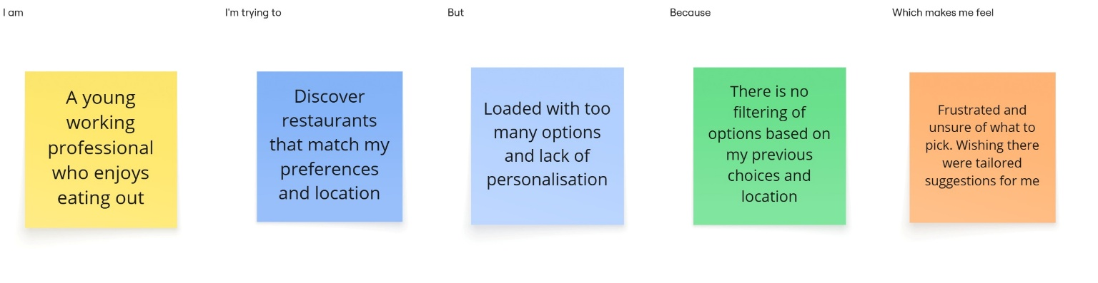

**PS-2**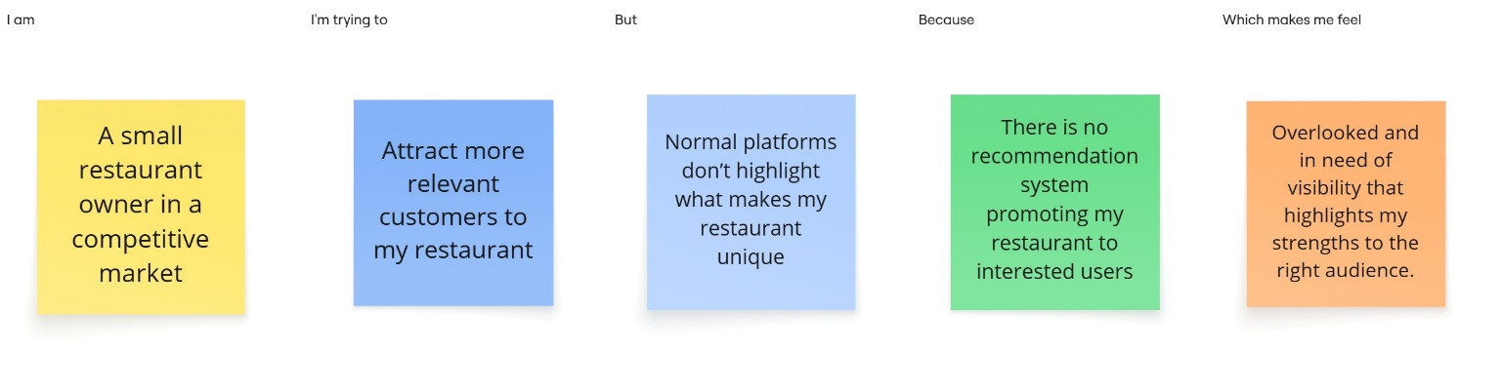

**PS-3**

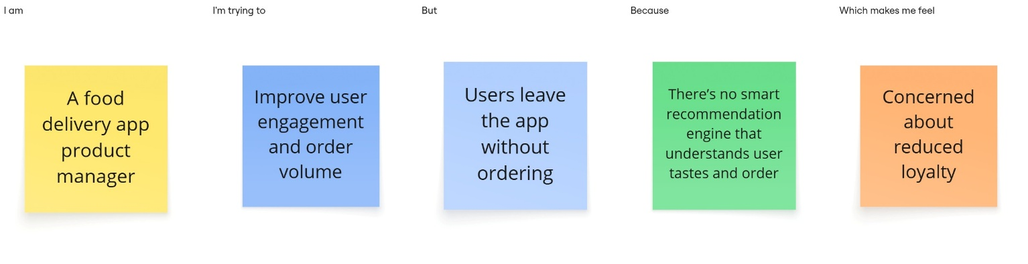

|  |  |  |  |  |  |
| --- | --- | --- | --- | --- | --- |
| **Problem**  **Statement (PS)** | **I am**  **(Customer)** | **I’m trying to** | **But** | **Because** | **Which makes me feel** |
| PS-1 | A young working professional who enjoys eating out | Discover restaurants that match my preferences and location | Loaded with too many options and lack of personalisation | There is no filtering of options based on my previous choices and location. | Frustrated and unsure of what to pick. Wishing there were tailored suggestions for me |
| PS-2 | A small restaurant owner in a competitive market | Attract more relevant customers to my restaurant | Normal platforms don’t highlight what makes my restaurant unique | There is no recommendation system promoting my restaurant to interested users | Overlooked and in need of visibility that highlights my strengths to the right audience. |
| PS-3 | A food delivery app product manager | Improve user engagement and order volume | Users leave the app without ordering | There’s no smart recommendation engine that understands user tastes and order history | Concerned about reduced loyalty |